Mission of the Month

**Stories from the global church spring 2014**

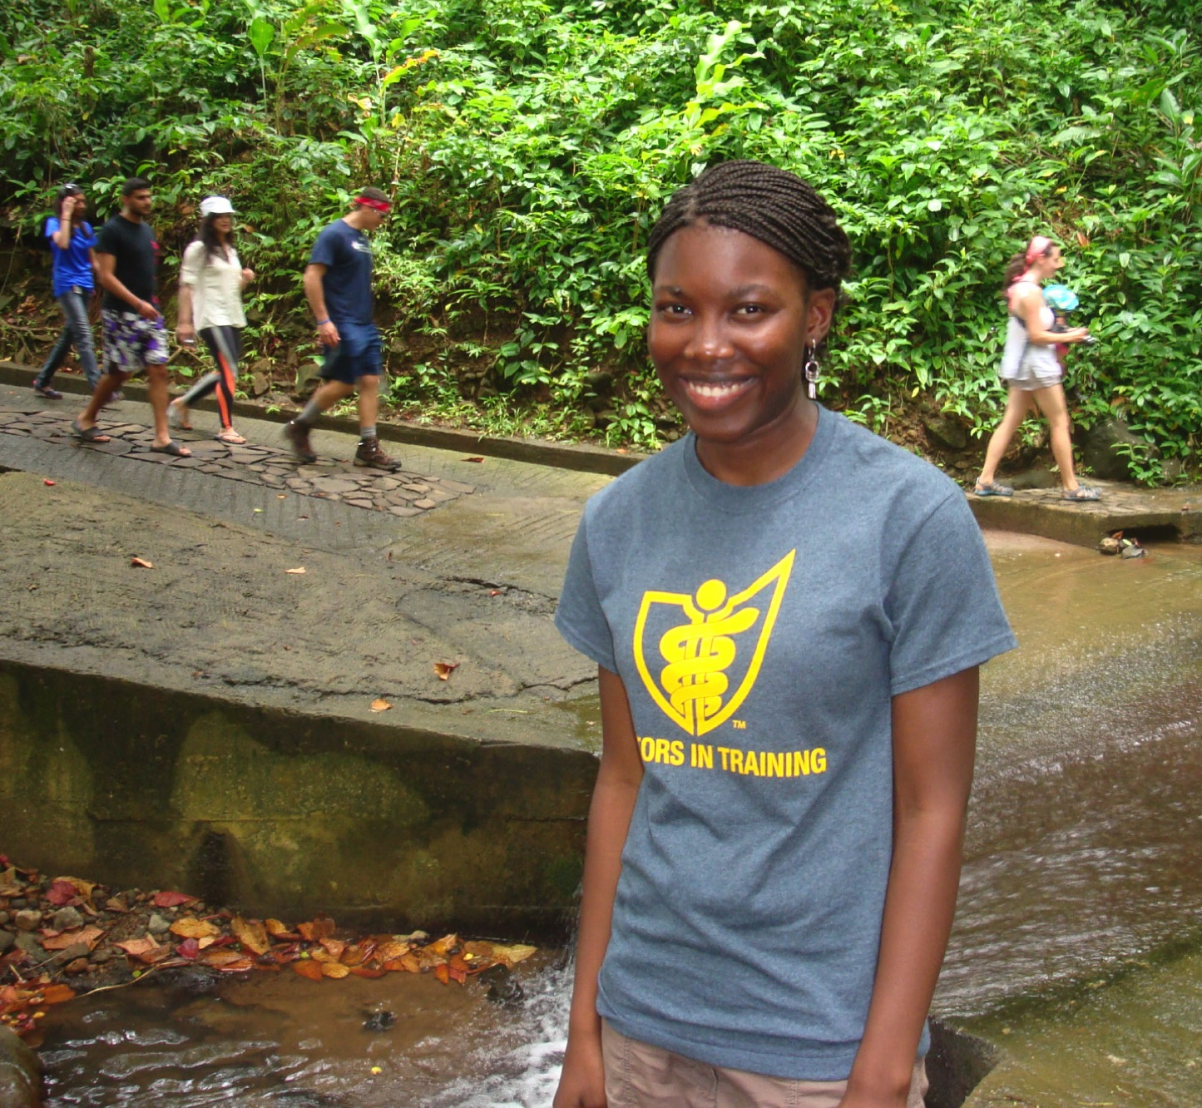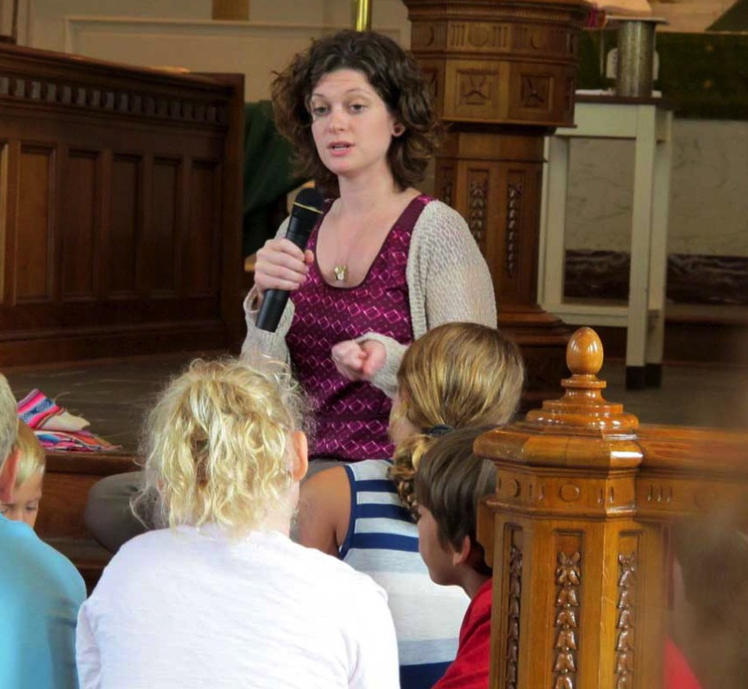

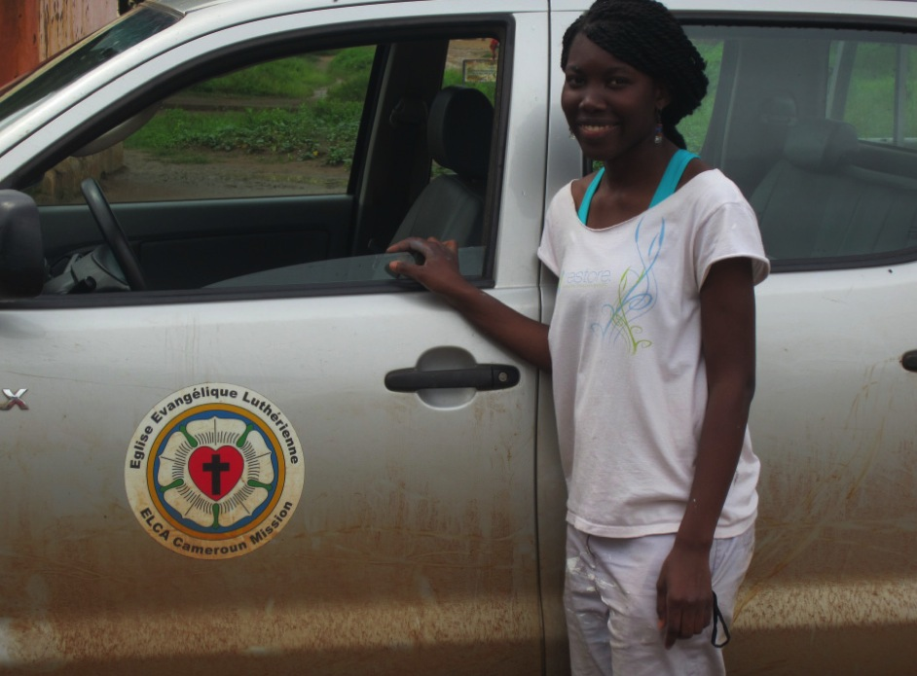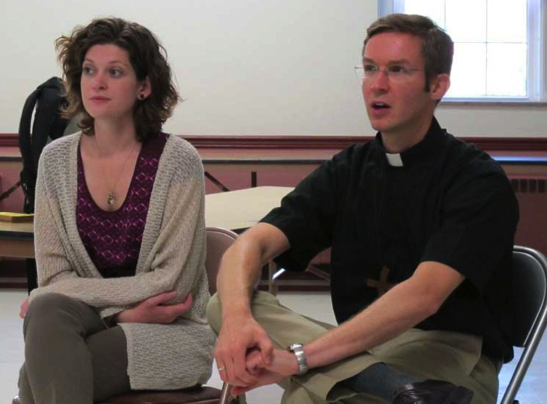

**cameroon   
LEFT:** *Nathalie Lassang, International Leader.* **BELOW:** *Nathalie enjoys  
a hike while studying   
at Ross University School of Medicine on   
the island of Dominica.*

**A priceless gift**

**Nathalie Lassang is an International Leader with a passion for medicine and for her home country of Cameroon.** “I have wanted to help ill people for as long as   
I can remember. My desire is to return to Cameroon to work there as a physician,” says Nathalie, who is now a medical student.

While growing up in Cameroon, Nathalie saw many people suffer from disease, and although she had always wanted   
to help people, she only began to consider a career in medicine when she began high school. One afternoon after church, a couple invited her family to their house for lunch. While talking with the husband, Nathalie learned that he was a surgeon and was inspired. When he asked her what she wanted to do, she knew that she wanted to get involved in medicine.

Now Nathalie is studying at Ross University School of Medicine, which is located on the Caribbean island of Dominica. She will finish there in May of 2016, thanks to a scholarship she received through the ELCA’s International Leaders program. One component of the program is that it requires participants to return to their home churches after finishing their studies. Once she completes her residency, Nathalie will return to Cameroon to serve as a physician with the Evangelical Lutheran Church in Cameroon. “I know that I can work as a physician anywhere in the world, but I feel my calling is to work in Cameroon. Being present with and comforting people is what I believe God has given me as a gift.”

Thanks to gifts from ELCA members like you, Nathalie is able to pursue her passion. “The education that I am getting is a priceless gift for which I am eternally grateful. I’m excited to go home and help the people in my community because I know that I will be able to make a difference.”

**Get involved!**

*Gifts to International Leaders – Women provide scholarships for women like Nathalie. Learn more at* [*www.ELCA.org/internationalleaders*](www.ELCA.org/internationalleaders)*.*